**PRODUCT BACKLOG REFINEMENT-SPRINT 5**



**Date:5/5/2017**

Contents

I. BACKLOG ESTIMATE EVIDENCES 3

1. Write review 3

2. Swappal staff ban user account 4

3. Staff view dashboard 4

4. User view review page 5

5. Staff view user list 5

6. Staff view user review 6

7. Staff adds skill 6

8. Staff View list skill 7

9. Staff edits skill 7

10. Staff delete skill 8

11. Staff view feedback list 8

12. Staff adds new category 9

13. Staff edits category 9

14. Staff views category 10

15. Exchange swap detail 10

# BACKLOG ESTIMATE EVIDENCES

## Write review

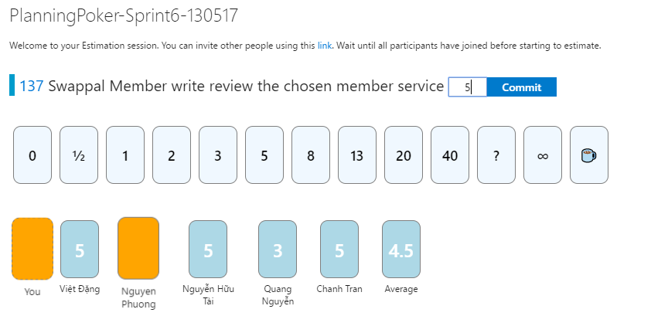

## Swappal staff ban user account

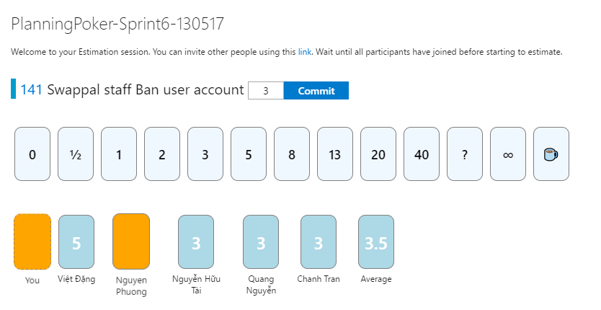

## Staff view dashboard

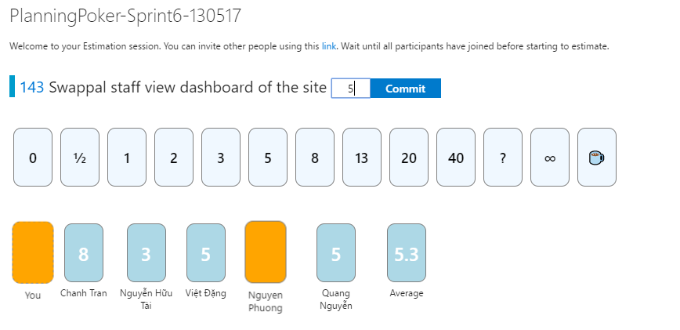

## User view review page

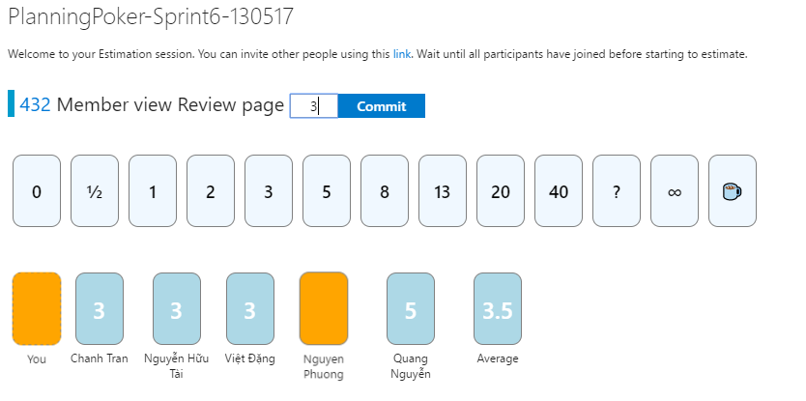

## Staff view user list

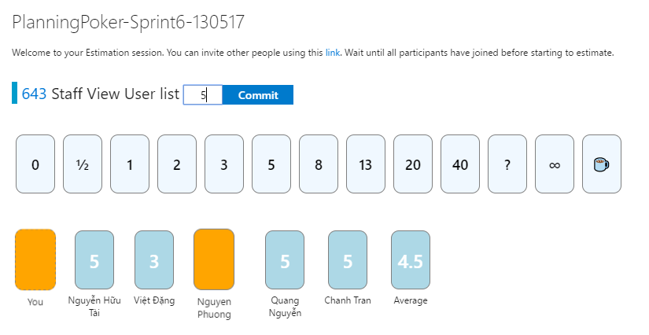

## Staff view user review

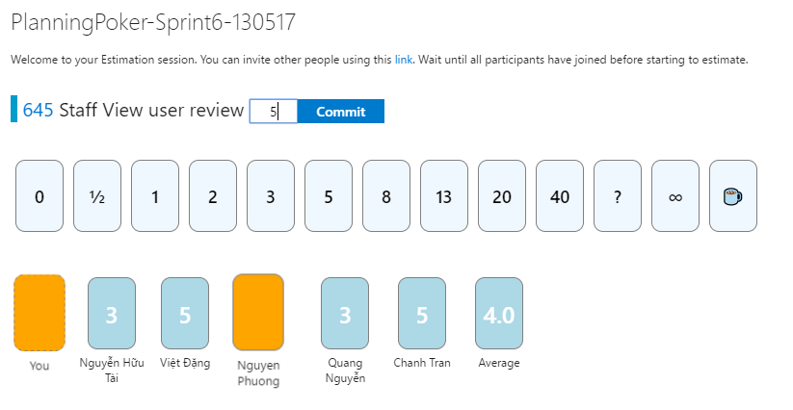

## Staff adds skill

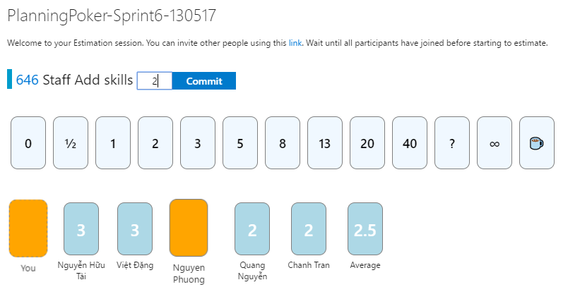

## Staff View list skill

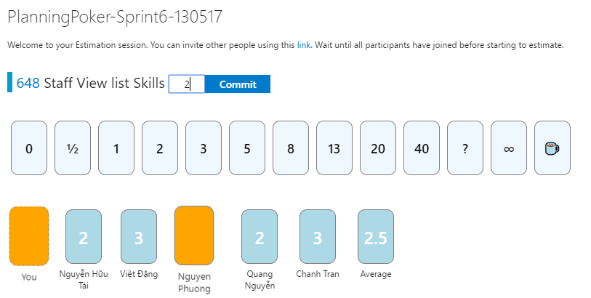

## Staff edits skill

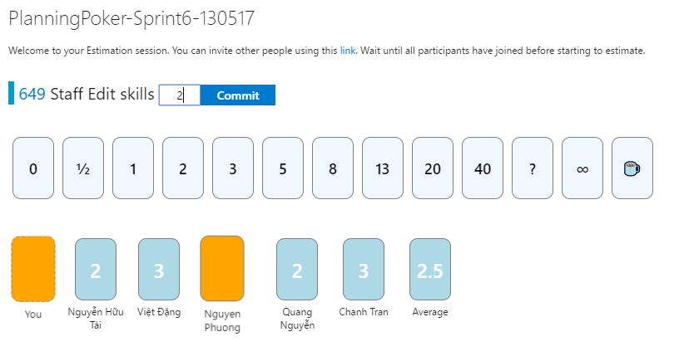

## Staff delete skill

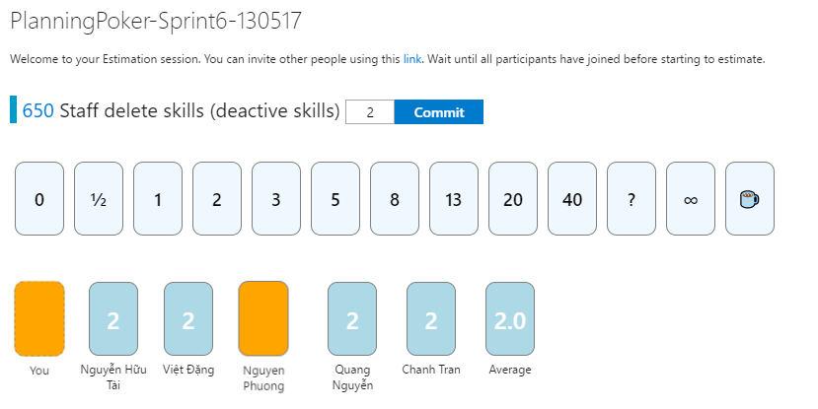

## Staff view feedback list

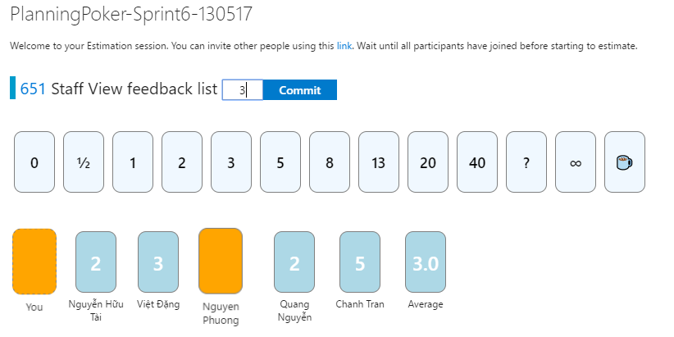

## Staff adds new category

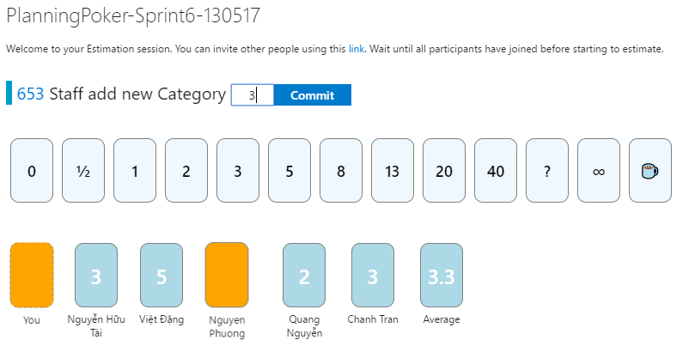

## Staff edits category

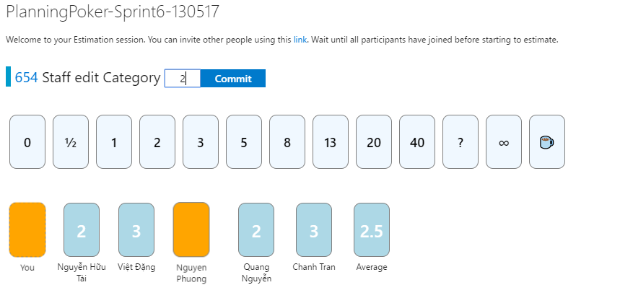

## Staff views category

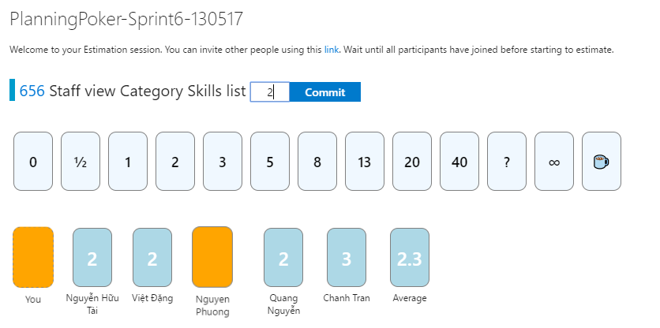

## Exchange swap detail

